PLANNING

MEMBERSHIP

The Planning Commission is comprised of nine (9) members, five (5) of which are appointed by the Marion County Mayor and approved by the Marion County Commission. The appointed members have staggered terms, and the other four (4) members’ services are coterminous and are comprised of:

Marion County Mayor
Marion County Road Superintendent
Two Marion County Commissioners

MARION COUNTY REGIONAL PLANNING COMMISSION’S
CURRENT MEMBERSHIP

Mack Reeves, Chairman, County Commissioner
Charles McEntyre, Vice-Chairman
Louise Powell, Secretary
Keith Garth, Alternate Secretary
Jerry Dempsey
Matthew Stone
David Jackson, Marion County Mayor
Jim Hawk, Marion County Road Superintendent
Matt Blansett, County Commissioner

Staff: Diana Chance, Marion County Planning Office, Planning Coordinator
Ashley Gates, Regional Planner, SETDD, Chattanooga, TN William Gouger, Marion County Attorney

The Marion County Planning Office is located at the Courthouse Annex at 24 Courthouse Square, Room 105, Jasper, TN. All plats should be submitted to this Office. The Marion County Subdivision Regulations can be downloaded from this website or picked up at the Planning Office. Our staff will be glad to assist with any questions regarding the platting process or registration of the plat.

MEETINGS

The regularly scheduled meeting of the Marion County Regional Planning Commission is the first Tuesday of each month, 4:00 P.M. CST at the Lawson Building located at 300 Ridley Drive, Jasper, TN 37347. To be added to the Agenda please call the Marion County Planning Office at 423 942 3527.

PLAT REVIEW DAY

Plat Review Day is held on the Tuesday two (2) weeks prior to each Planning Commission meeting. All plats must be submitted to the Marion County Planning Office no later than Noon CST of Plat Review Day in order to be placed on the next meeting’s Agenda; otherwise it will be placed on the following month’s Agenda. Two (2) copies of a plat are required to be turned in for plat review unless new roads are involved and then three (3) copies are required. Plats can be submitted to the Planning Office during regular business hours Monday through Friday.

TYPES OF PLATS

Staff Approved Plat containing two (2) lots or less, requiring no improvements or variances and are in compliance with the Subdivision Regulations can be approved by Staff. After review of the Final Plat by the Planner, eight (8) copies of the plat with original signatures on all copies are required to be submitted to the Planning Office for the Planning Commission’s Staff’s and Secretary’s signatures.

Preliminary Are required in subdivisions which have five (5) or more lots. After review by the Planner, six (6) copies are required for the meeting. If a utility company is involved, the appropriate agency should be contacted at or before the Preliminary Plat stage. This plat must receive the Planning Commission’s approval prior to Final Plat Approval.

Final: Are required for all developments. After review by the Planner, eight (8) copies of the plat with original signatures on all copies are required for the meeting for the Planning Commission’s review and approval and/or denial.

The Planner reviews plats upon submittal, contacts the appropriate surveyor with corrections, if any, and reviews the plats again prior to the meeting.

ZONING

There is no zoning in unincorporated Marion County.

PLAT REGISTRATION

Once plats receive Final Plat approval from the Planning Commission, the Plat must be registered at the Marion County Courthouse in the Register of Deeds Office. Until this is done, the plat is not a legal document, and lots cannot be sold.

SIGNATURES ON PREVIOUSLY RECORDED PLATS

In accordance with State law a revised plat, which is a re-subdivision of a portion of a previously approved Subdivision that is on file in the Register of Deeds Office, shall only be required to have the surveyor’s, Owner’s and Planning Commission Secretary’s certification blocks and signatures on the plat when requesting Final Plat Approval.

In most cases, even though it only requires the three (3) signature certification blocks, it’s still required to come
back before the Planning Commission regardless of the number of lots. These plats still must go through the same approval process.

SIGNATURES REQUIRED FROM THE FOLLOWING AGENCIES ON MOST FINAL PLATS

Sequachee Valley Electric Coop. 423 837 8605 512 Cedar Avenue, South Pittsburg, TN
9 1 1, Jerry Don Case 423 942 4423 105 West First Street, Jasper, TN
TDEC (Septic) Skip Skotte 423 240 0965 No Office, only reachable by phone.
Marion County Road Superintendent 423 942 2581 513 East Valley Road, Jasper, TN
Planning Commission Secretary 423 942 32527 24 Courthouse Square, Room 105, Jasper, TN
Any Existing Water or Sewer Company

* In order for TDEC to obtain the necessary soil analysis prior to their signature being placed on a Final Plat, they should be notified at the Preliminary Stage of your development.

MARION COUNTY SUBDIVISION REGULATIONS

The Subdivision Regulations for unincorporated Marion County, Tennessee are prepared by the Marion County Regional Planning Commission and assisted by the Marion County Planning Office. This seventy-two-page document is on the website for your convenience. You must have Adobe Reader on to access it.

Subdivision Regulations for Marion County, TN may be downloaded from the website

MARION COUNTY BUILDING

Marion County adopted and the Building Inspector enforces the following 2012 editions of the International
Codes:

1. International Building Code;
2. International Existing Building Code;
3. International Fire Code;
4. International Fuel Code;
5. International Mechanical Code;
6. International Plumbing Code;
7. International Property Maintenance Code, and
8. International Residential Code.

AMERICAN DISABILITIES ACT

Marion County enforces Volume 1-C of the 1999 North Carolina Accessibility Code.

FEMA

Any property lying in the floodplain or if a property’s elevation is questionable, a Flood Elevation Certificate
must be submitted prior to issuance of a Building Permit.

The Marion County Building Inspector was appointed to administer and implement the provisions of the
County’s Floodplain Resolution covering unincorporated Marion County.

LICENSED CONTRACTORS

This link allows you to access the State’s website to determine if a contractor is licensed.

Link to the Roster for Licensed Contractors for the State of TN:

http://verify.tn.gov/

BUILDING CODES INFORMATION

Individuals can purchase Building Code books at the ICC website and obtain other valuable information.

Link to the Building Codes is:

http://iccsafe.org/

PROCEDURES FOR OBTAINING BUILDING PERMITS

- The application process for a septic system can be filled out online at: https://tdec.tn.gov/septic. You are required to bring a copy of the receipt showing your payment as well as any associated paperwork when coming to apply for your building permit. If an existing septic system is going to be used, you will need to obtain a Verification of System form. If you have any questions regarding this call Skip Skotte at 423 240 0965 or TDEC in Chattanooga at 423 634 5745.

2. Two (2) sets of blueprints or drawings to scale.

3. Tax map and parcel numbers of the property the structure is going to be located on.

4. 9 1 1 address for the property. The address must be posted on the building prior to requesting an
inspection. To obtain a 9 1 1 address contact Jerry Don Case at the 9 1 1 Office, 423 942 4423 or
email jdcase_911@yahoo.com.

With the above information, you may complete an Application form for a Building Permit. Once the application is submitted, it normally takes 24 to 48 hours for the building permit to be ready to be issued. At that time, you will pay the permit fee, receive your permit and one set of plans. Your plans must remain on the job site at all times.

A Job Box must remain on site at all times!

MINIMUM SETBACKS

Minimum Setbacks: Are measured from the property lines, not the road or right-of-way. The minimum setbacks allowed are:

Front – 40 Feet; Side – 15 Feet; Rear – 15 Feet

REQUIRED INSPECTIONS

1) Footings: After trenches have been opened, steel is in place, grade stakes set, and termite treatment applied. You must have a copy of your termite treatment letter or receipt. Prior to any concrete being poured. Don’t schedule your inspection for the day you want to pour.

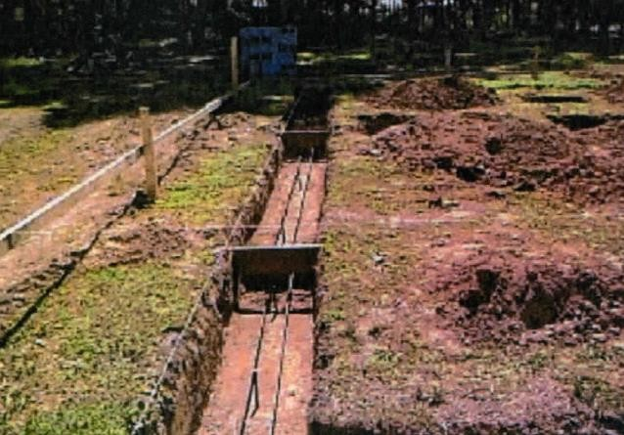

2) Foundation: After the foundation has been laid, anchor bolts in place and all topsoil and debris removed from crawlspace. Crawlspace should be graded for drainage.

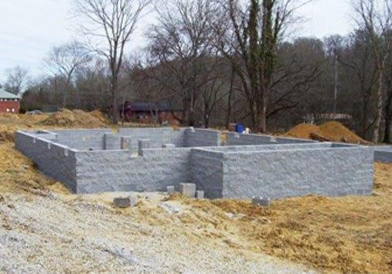

3) Rough-in: After all framing, bracing, rough-in wiring, mechanical, and plumbing are in place. Before the inspection can be completed the plumbing must be pressurized on the incoming and water standing in drains to the highest point inside the structure. Do not insulate the structure or cover the interior walls.

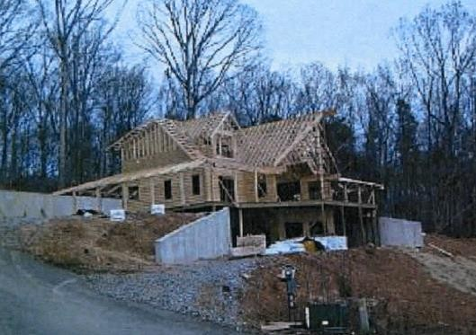

4) Final: Before the structure can be inhabited it must be complete. All safety features shall be in place i.e., smoke alarms, c.o. detectors, handrails, and guards. If possible, the exterior of the structure shall be graded for the proper water shed (weather permitting).

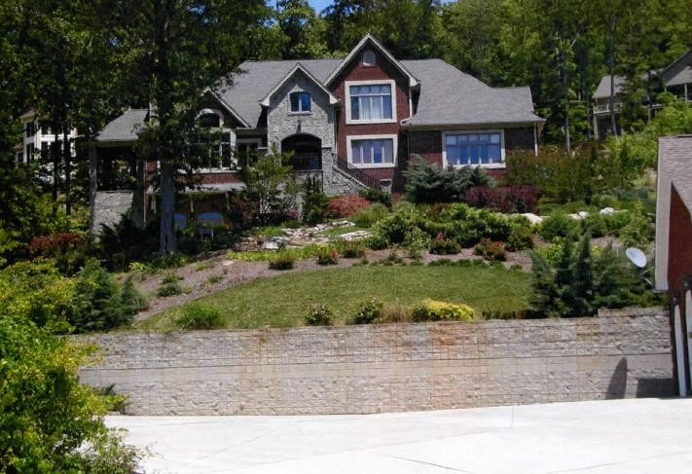

SCHEDULING INSPECTIONS

To schedule an inspection please call 423 942 8019.

You must have the following information to give Staff in order to schedule an inspection:

1) Building Permit Number
2) Street Address and Directions
3) Name of Owner and type of inspection being requested

Inspections are scheduled Monday through Friday 8:00 A.M. – Noon CST and 1:00 P.M. – 4:00 P.M. CST. We do not schedule appointments and therefore cannot provide a specific time that the Inspector will arrive.

Footings will be inspected first.

REQUESTS FOR BUILDING INSPECTIONS LEFT ON OUR ANSWERING MACHINE
WILL NOT BE SCHEDULED!

BUILDING PERMIT PACKAGE

The Building Permit Package includes the following:

1. Procedures for Obtaining Building Permits *
2. Procedures for Scheduling Required Building Inspections *
3. Items Required when building a new house *
4. Requirements of Areas which may have Unstable Soils prior to the Issuance of a Building Permit * The above are included in this document, Procedures and Requirements and are not separate
forms/documents
5. Owner/Builder Agreement
6. Application for Building Permit
7. Plumbing Permits
8. Mechanical Permits
9. Installation of Metal Buildings, Barns and Sheds

The above items can be downloaded from the website.

MOBILE HOME PERMITS

To obtain a Mobile Home Permit you must submit the following:

1. A copy of your septic application;
2. Tax Map and Parcel Numbers of the property, and
3. 9 1 1 address. To obtain a 9 1 1 address contact Jerry Don Case at the 9 1 1 Office, 423 942
4423 or email jdcase_911@yahoo.com.

With the above information, you can apply for a Mobile Home Permit. Marion County has a Mobile Home Resolution in place that states all mobile homes must be placed on an individual lot. The lot sizes are as follows:

a. If there is public water on the property the minimum lot size is 15,000 square feet, and b. If there is well water the minimum lot size is 25,000 square feet.

MINIMUM SETBACKS

Mobile Home Set Back Requirements are:

Front – 40 Feet; Side – 15 Feet; Rear – 25 Feet

In accordance with State Law, mobile homes must be setup by a licensed installer with the State of
Tennessee.

AREAS WHICH MAY HAVE UNSTABLE SOILS ARE REQUIRED TO
HAVE THE FOLLOWING PRIOR TO ISSUANCE OF A BUILDING PERMIT

1. Elevation Certificates are required for all property adjacent to the river or any low-lying areas which might be in the floodplain.

2. Stability of the Soil must be checked by a Geotechnical Firm and a report of their findings must be sent to the Building Inspector.

Based on the results of the soil tests, engineers may be required to design and/or inspect the footings and/or walls of the structure to ensure stability.

3. You must have the lot checked and approved by TDEC for use of a septic system. This approval
must be submitted with your Building Permit Application form.

4. If the lot doesn’t have a public water supply, the lot must be a minimum 25,000 square feet.

5. Plot Plan (showing how the structure will set on the lot) must be submitted with the Building Permit
Application.

6. Every lot must adjoin and/or abut a government-maintained road for at least 50 feet.

7. A copy of the Tax Map (with tax map and parcel number) of the parcel of property to be built on must
be submitted with the Building Permit Application.

*TDEC Tennessee Department and Environment and Conservation

